A Graphics game engine in 3.5 Dimensions

Martin Goulet

Supervision by Dr. Jochen Lang

December 2005
School of Information Technology
University of Ottawa

Abstract
The computer game industry has been growing at a fast pace in the last decade. However, a large portion of modern 3D games has been released with an obvious lack creativity and imagination. The goal of this paper is to introduce a concept that has never been applied to 3D action games. It reduces the traditional constraints of the genre, thus allowing a greater application of creative development. Using a fourth axis and a limited virtual extension of 3D space, the Hyperbelt concept seeks to open a window of creativity and imagination for 3D action game titles to come. Secondary key points, namely collision detection and particle dynamics will be discussed as well. These will support and reinforce the applicability of sthe Hyperbelt in today's 3D game industry.

Table of Contents

1 Introduction 4

2 The Hyperbelt Concept 6
  - Introduction 6
  - Challenges of True 4D Environment 6
  - Multi-layered 2D Environment 9
  - Hyperbelt Explained 10
  - Collision Detection in a Hyperbelt Environment 12
  - Particle Dynamics in a Hyperbelt Environment 13

3 Technical Specifications & Implementation 14
  - Selection of Tools 14
    - The Programming Language 14
    - The Graphics Library 15
    - The Input Library 15
    - Environmental Assets 15
  - Selection of Framework 16
    - Overview of Phase4 Architecture 16
    - Functionality of Phase4 17

4 Prototype Implementation 17
  - Particle Dynamics 17
  - Collision Detection 18
  - Hyperbelt 19

5 Conclusion 20

6 Appendix A 21

7 Glossary 25

8 References & Resources 26

A Graphics game engine in 3.5 dimensions

The success of a computer game title relies on several key aspects. An experienced programmer writing code in his free time can no longer determine the success of a game. The complexity of these games has increased drastically over the last decade, which forces game development teams to focus on several different game aspects in depth.

Game aspects like technology and creativity are among the most important, determining the fate of computer games in the market. In the past decade, significant improvements regarding each of these factors has been made, in order to keep the gaming community entertained by the games that hold them. Technical components such as 3D and AI engines have lead the way to a variety of game types, such as first person shooters, role playing games and real-time strategy. Alongside this technological growth, creativity led the way to the realization of fantasy worlds, story lines and fascination throughout the gaming experience.

In today's games, technology alone is insufficient to drive a game out successfully, since the lack of creativity would not keep the players entertained for a long period of time. Creativity cannot solely support a game either because the forces of competition would drag the interests of users towards more appealing games, which contain new features only available by more complex software architectures. Both of these key points must work together, since they are somewhat correlated. In order to allow a certain level of creativity in a game, appropriate resources and methods must be available. Equally, software designers need a purpose or goal for the implementation of software in order to create a realistic framework for the game.

The current 3D game industry is ever growing, and the income from it surpasses that of the movie industry. This illustrates the influence of gaming in our society as well as the relative size of that market. From a personal perspective, I believe that the concept of the typical Action 3D game has started to lose impact on the gaming community, since most games in this genre are very repetitive.

When titles such as Wolfenstein and Doom were first released in the early 1990's, their impact on the computer game industry was immense. This was so because these titles offered brand new features; the technology used in those games was unmatched, and the level of violence and gore had never been so extreme. Ironically, similar games are released nowadays, but have very little impact on the community, since many are considered as recycled recreations of the older classics. It seems as though the element of creativity has been lacking in this specific genre.

In this paper, a new concept, namely the Hyperbelt Concept will be discussed. The goal is to expose the reader to a fresh idea, which could potentially change the face of modern 3D gaming. In support, two specific subtopics will be covered, since they are very closely related to the concept. These subtopics are collision detection and particle dynamics.

The idea behind the Hyperbelt is to extend the original 3D game environment with an additional axis. Each entity in the game system will have a 3D position as well as a fourth coordinate representing its location on this additional axis. Travel through the initial 3D space would remain similar to most modern games. Additionally, the user will have control over this extra component using a threshold that will determine the proper 3D environmental slice in which his controlled entity resides. That is, the entities would travel in 3D as well as through parallel 3D environments. This fourth component would be subject to change within specific bounds and would be bent in a circular fashion. Both extremities would be connected, creating a circle

Collision detection will have to be interpreted differently, and its computation will have to take this fourth component into consideration. Particle dynamics will also adapt to this concept, giving the user an isolated dynamics system that solely controls the entity's fourth coordinate (position on the hyperbelt).

The next part of this paper discusses the concept explanation in depth. This includes the hyperbelt, the applications of collision detection in such an environment as well as particle dynamics. These discussions are followed by a technical discussion, regarding the technology used in the creation of the prototypal framework. The goal of that section will be to give an example in real-time, giving a better perspective on the entire concept. Afterwards, the prototype will be discussed and direct links will be made to the actual implementations of these concepts.

The Hyperbelt Concept

Initially conceived to be applied in a three-dimensional environment, the Hyperbelt concept can be applied to environments consisting of n dimensions. In order to discuss the idea in depth, this section was broken in several parts.

First, a short discussion about implementing a free-rotation 4D environment followed by some challenges and complexity issues related to navigation of such an environment. Secondly, the hyperbelt concept will be applied to an example in two dimensions, followed by the interpretation of collision detections in such an environment. Thirdly, particle dynamics will be discussed, and the hyperbelt concept will be described in relation to a3D environment, in the context of a flight simulator.

2.1 Challenges associated with a free-rotation 4D environment

The implementation of a simulator permitting the user to navigate in four dimensions is by no means an arcane application of algebra. Despite the complexity of its interpretation by the human mind, the logical structure remains fairly simple and similar to that of a 3D environment. Navigation through such an environment could require the user to manage the equivalent of six Euler angles, which, despite the strong understanding of a 3D space, can become very difficult to conceptualize. Alone, the human-computer interaction (HCI) challenges would be very high and hardly conceivable using the standard user-interface peripheral set provided with most modern computers. For this reason, the idea of game-related research in four dimensions has been aborted and replaced by a simpler solution, the Hyperbelt concept.

  - Multi-layered 2D environment

We shall begin our concept discussion by comparison with a popular arcade hit. Figure 2.1 illustrates a simple 2D environment from a very popular and classic arcade title: Pacman. One of the critical objectives in this game is to avoid collisions with the ghosts at all costs. The ghosts are free to move wherever they wish in order to capture pacman on this 2D plane.
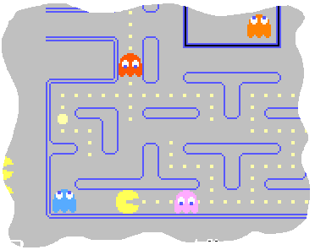
Figure 2.2.1 Extract of a terminal Pacman scenario
In this scenario, Pacman is trapped between two ghosts. Following the rules of the traditional arcade game, there is no way for the user to save pacman, in the case that both ghosts are moving towards him. This is a terminal situation for the player. However, if the player could travel in a space larger than the game platform itself, he could be saved from this situation. For instance, instead of moving on the game surface determined by the X and Y-axis, he could travel in a direction perpendicular to the game surface, namely, through the Z-axis. Figure 2.2.2 illustrates the same scenario from a different perspective. From this point of view, we can expand the entire environment further onto the Z-axis, creating a 3D space.

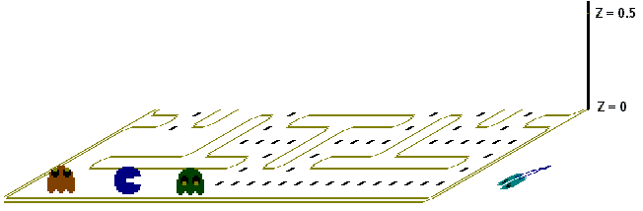
Figure 2.2.2 Expanding the game space in 3D

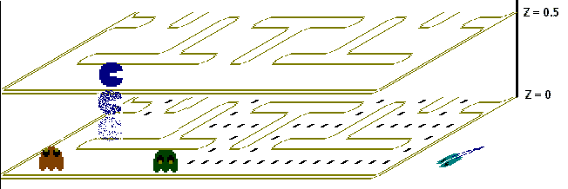
In this figure, the game space in no longer limited to a 2D environment, although it is still a plane. There could be a way, however, to fix the behaviour of the game plane in a static fashion throughout the Z-axis. The initial game place could be replicated infinitely and each replication could be stacked on top of the previous one. That way, the game entities could travel in the same XY fashion on the game plane as they used to, but in addition, they could vary their location on the Z-axis without having the game plane change it's apparel. This effect could be compared as standing still in a flat maze, waiting for time to go by, associating the Z coordinate in this example as being the time passing by. Figure 2.2.3 illustrates the same scenario where Pacman is using the X coordinate to escape from the ghosts.
Figure 2.2.3 Pacman escaping the trap through the Z-axis
In this figure, Pacman is theoretically safe from colliding with the ghosts, since the distance between him and the ghosts involves more than the XY plane from the initial game environment. At this point, Pacman is on a completely separate plane. The user could control him eastward safely as he pleases, avoiding the ghosts completely as shown in figure 2.2.4.

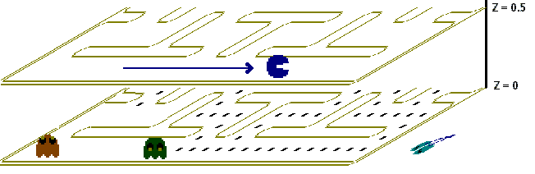
Figure 2.2.4 Travel on a parallel plane

Unfortunately for Pacman, his goal is to collect all the dots that are all on the initial plane. He would then be forced to travel back on the initial plane (which intersects the Z-axis at the origin) in order to finish collecting the dots. This move is shown in figure 2.2.5.

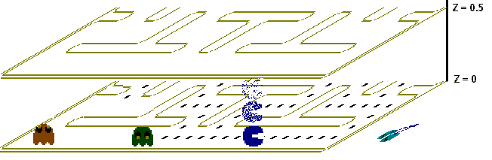
Figure 2.2.5 Pacman returning to the initial game plane

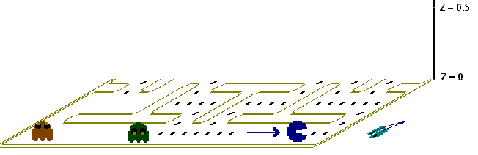
Using the Z-throttle to return, pacman shifts once more through the Z-axis. He stops throttle when Z = 0, which is the location of the initial game plane. Once back, he can continue to travel and collect the dots throughout the map, as shown in figure 2.2.6.
Figure 2.2.6 Pacman safely collecting dots once again

This entire scenario demonstrates how Pacman could evade the ghosts safely and continue his quest, as long as he has a grip on the Z-axis. This might not seem like a fair game, but we could add to this scenario by letting the ghosts navigate through the Z-axis as well. In this project, the tern hyperfactor will be used to describe an entity's position in the Z-axis.

2.3 Hyperbelt Explained

The hyperbelt is a small variation of the concept discussed in the previous section. In the latter, the Z-axis was fixed as being perpendicular to the game plane. This remains true with a hyperbelt. First, lets re-scale the Z-axis from 0 to 360, which will later be associated with degrees. Also, we shall modify the layout as well as the navigation through this axis. As the name of the concept implies, we will form a circle from this axis, which will be called the hyperbelt.

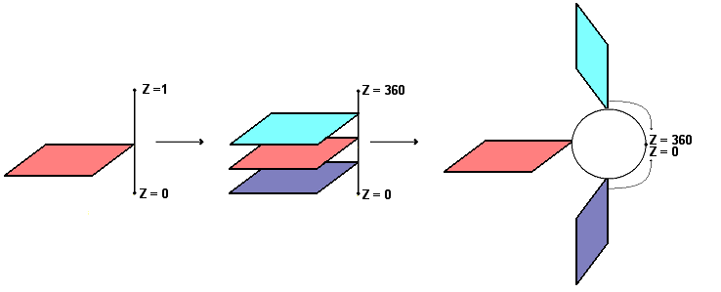
To change the looks of the axis from a line to a circle, let’s assume that the position of the entities in that Z-axis is limited by the function mod (360). Therefore, the Z coordinate could be incremented infinitely, but would always reside in the range between 0 and 360. The hyperbelt concept gets its name from this restriction. As shown in figure 2.3.1, the Z-axis is bent, linking the infinite set of parallel planes (which are perpendicular to this axis) onto themselves, forming a belt.
Figure 2.3.1 The Z-axis converted to a Hyperbelt

Despite the modified scale, navigation through this bent axis would be quite similar to the navigation of a straight-line axis, with one exception. For example, let B be the size of the belt (360 in this case), C be the current position of the entity on this axis and T be the travel distance of the entity. Then, if the entity travels a distance T that equals B, then it finds itself at the exact same place as it was before, since C*mod(B) = (C+T)*mod(B), if T = B.

Returning to the Pacman scenario, the user could increment Pacman's hyperfactor as much as he pleases. Once the Z value approaches 360, however, Pacman would reach the exact same spot as he started, but this time approaching it from beneath. The reason behind the scale size of 360 is to make the association between the belt-like axis and the trigonometric circle. Instead of creating a new scale, it was with the intention of familiarizing the users to use a commonly use scale. In practice, the axis could be scaled in any manner; it would not change the properties of the concept. But if the trigonometric circle were associated, then a hyperfactor of 180 would be clear to anybody familiar with trigonometry.

2.4 Collision Detection in a hyperbelt environment

Fundamentally, the hyperbelt concept is a relatively simple addition to an environment of any dimension. However, several challenges arise in the interpretation of certain other concepts, such as entity displacement and collision detection. Interaction between two objects generally occurs only when they attempt to occupy the same space at the same time [LENG04]. In the case of a 2D environment, collision detections are usually made with bounding shapes of a static size. Squares and rectangles are usually good candidates for robust 2D-collision detection. For instance, such a system could represent a moving car entity by a rectangle or circle that would encompass the entire car image, as shown in figure 2.4.1.
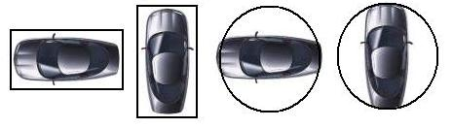

Figure 2.4.1 Bounding Volumes of a 2D model

Such bounding shapes are quickly generated during collision tests. The rectangular examples in figure 2.4.1 are often referred to as OBBs (Oriented Bounding Boxes), where the box's structure is function of the entity's position and orientation. An even simpler solution would be to create a box of static size, and make it independent of the entity's orientation. These are called AABBs (Axis Aligned Bounding Boxes).

Circles are also easy to manage, since they are defined by a simple radius, and are independent of the object's orientation, by nature of the shape. The same concepts are applicable in a 3D environment, replacing the notion of squares by cubes and prisms, and circles by spheres.

In a hyperbelt environment, however, things get a little more complicated. The degree of a bounding volume must be one degree higher than that of the environment in context. For example, an object in a 2D-hyperbelt environment (such as in the Pacman scenario) would need to have the complexity of a 3D object. This would be so because each object would need more than a 2D shape to cover their entire surface, since every entity should have a thickness associated throughout the Z-axis. Lets consider figure 2.4.2, which represents figure 2.2 one last time, looking down the Y axis.

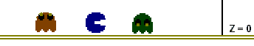
Figure 2.4.2 A side view of the 2D game environment

If Pacman were to pursue the previous scenario (evade the ghosts using the hyperbelt), to what hyperfactor would it be sufficient to travel, in order to safely evade the ghosts? If we were dealing with a series of mathematical planes, in theory, the slightest change in Z would suffice. Trying to find solution for collision would yield an indefinite result, since all the environmental planes in a hyperbelt system are parallel to each other. However, if we wanted to make things a little more interesting and applicable to gaming, we could introduce the notion of a hyperscope. The hyperscope would determine the effective range of each entity throughout the hyperbelt. In order to compute a valid collision, there would be two requirements:

  - First, ignoring the hyperbelt, there must be space in the 2D environment that is covered by the bounding circles of both entities. This situation would return a collision if no hyperbelt were present.
  - Secondly, the distance between the hyperfactors of both entities would have to be shorter or equal to the sum of both hyperscopes.

Lets assume the hyperscope of the entities were exactly the size of their graphical representation from figure 2.2.2. In this case, figure 2.4.3 illustrates the same scenario found in figure 2.2.2, with the minimal hyperfactor increase necessary in order to safely cross over the pink ghost in a parallel plane.
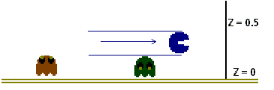
Figure 2.4.3 The minimum necessary hyperfactor to avoid collision

In this diagram, the pacman entity evades the ghost, since at most one of the aforementioned collision requirements were satisfied during the entire sequence. Looking down the Z-axis, both entities would seem to collide. However, they are not on the same plane. If the pacman entity would have incremented its hyperfactor to half the distance in this diagram, there would have been collision between both entities. This would have triggered a terminal situation for the player.

  - The Hyperbelt and Collision Detection In A 3D Environment

As mentioned before, the hyperbelt concept applies to environments of any dimensional size. Because of this, the differences between a hyperbelt in a 2D-environment set and that of a 3D-environment set are slim. The set of 3D environments that complete the hyperbelt are stacked and navigated just like in the 2D pacman example, although it might be difficult to visualize. Entities would be free to navigate through three dimensions using standard rotation and movement routines found in most 3D-simulation games, as well as navigate through the hyperbelt using a completely separate displacement system.

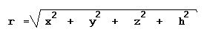
For a 3D-hyperbelt environment, collision detection would strongly resemble the 2D scenario as well, since the same technicalities arise. In the latter, we have used a bounding entity that consisted of three dimensions (N+1, N being the degree of the initial environment). This sphere, intersecting with the plane of each entity could then be interpreted as a circle, with a radius that was also function of the entity's hyperfactor. If we follow the same idea, the 3D scenario would use a bounding volume of the fourth dimension, the hypersphere. We could then use the hyperfactor as part of the hypersphere's equation, illustrated in Figure 2.5.1.
Figure 2.13 Equation of a hypersphere

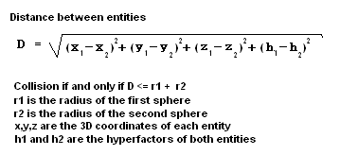
Each collision test could then consist of a distance comparison between two hyperspheres to the distance between both entities, including the hyperfactor.
Figure 2.5.2 Collision requirements for hyperbelt in 3D

This simple extension from 3D spherical intersection would be easy to manipulate, and the extra computation costs are relatively negligible.
However, since the hyperbelt concept keeps both navigation systems (the initial environment and the hyperbelt) perpendicular to each other, the hyperfactor can be removed from the sphere's equation, and used as a simple entity distance check through the hyperbelt. For this reason, before computing the collision detection between two entities, we perform a logical operation that rejects the collision test under a certain condition; if the hyperdistance between two entities is greater than the difference of their hyperfactors (including each entity's hyperscope), then the collision is rejected.

This further reduces the costs of collision tests, since a numerical comparison is relatively free to compute, compared to any type of volume intersection. If the entities' hyperscopes do not intersect, then neither do their bounding volumes of the lesser dimension.

  - Particle Dynamics

In a classic 3D environment, particle dynamics manages the way selected entities move and react when forces are applied upon them. Furthermore, each entity is treated like a mathematical point, or simply put, a particle. This allows objects to have limited physical properties, which could mimic more complex calculations at a satisfying degree.

Due to each object's degenerated form, no information regarding size or shape is required, since the body has been degenerated to a point. However, the following data sets are still required: position, velocity, acceleration, mass and the applicable set of forces. For the scope of this project, however, only the aforementioned components were necessary. These components were used for particle dynamics in the 3D environment, and a duplicate set was uniquely used for the hyperbelt travel. Please consult Figure 2.6.1 for the data sets used by the entities. Each column represents a different vector set used by the entities.
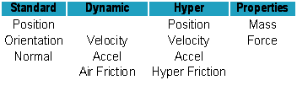
Figure 2.6.1 Components used for Particle Dynamics

Particle Dynamics through the hyperbelt could have been interpreted in several ways. However, a somewhat simplistic and sufficient model was used. As mentioned before, navigation throughout the original scene was completely separated from that through the hyperbelt. Similarly, particle dynamics followed the same scheme.

Technical Specifications & Implementation

Most of the topics in this section discuss the choices that were made prior to this project, which are directly related with the architecture of the game engine used as the foundation framework.

3.1 Selection of language, libraries and assets

Choosing tools for the implementation of Phase4 was not done with the roll of a die. Several requirements had to be met, including speed, reliability and usability. This section discusses and justifies the selection of each key tool used in the framework's construction.

3.1.1 The Programming Language: C++

In order to demonstrate this concept in real time, a prototype had to be made. When came the time to select a language for implementation, there were four main concerns: Control, Design, Resources and Independence. The prototype needed to be constructed by an imperative-programming context (due to personal preference), which was believed to be wise choice for a real-time 3D application. Some Modern programming languages working in this fashion were Pascal, Java, C and C++. With those four programming languages in mind, the assessments of the four aforementioned principles were applied.

First, the accessibility of online help and resources were important. It was believed that the task at hand was a difficult one, and help would be indispensable in large amounts. It would be an advantage to have an implementation written in a language that would be commonly practiced at the time, and be fully compatible with other resources that had been planned to be in use for the engine such as graphic and input libraries. This criterion knocked Pascal off the list, since it is a language that had very little support from the game industry, compared to the other candidate languages.

Secondly, there was a need for a language that was robust, and could give control over low-level memory management. The principle reason for this criterion was that the prototype being built dealt with a fast-paced real-time 3D environment. Several assets, such as textures and 3D models, would be loaded and released dynamically during the application lifetime. Common languages in this category were C and C++. Although Java would have been a good candidate in general, it lacked the freedom of memory management that was deemed necessary. C and C++ were very commonly used in the 3D game industry, and the power of applications using these languages was becoming clear.

Thirdly, Design flexibility and the opportunity to reinforce object-oriented knowledge was significant, to keep a clean, readable and adaptable design for the prototype at hand. C is very powerful for this type of application and had been used for so many game engines, such as the Doom and Quake series, but lacked some appealing features found in C++. Hence, the choice of language was C++, which was believed to be a powerful all-around language for the type of application planned.

3.1.2 The Graphics Library: OpenGL

Just as there are several programming languages applicable for this project, there are almost as many graphic libraries to select from. Although the selection of programming language could be considered as justified, the selection of a graphics library was not as thoroughly analyzed. The main goal of this prototype was not to make heavy use of a graphics library and all it's features. On the contrary, this prototype was intended to be able to interface with any type of graphics library, using a set of versatile library wrappers. The final choice was to use OpenGL over Direct3D, which seemed more procedural than the latter.

3.1.3 The Input Library: DirectInput

The initial input library used for the application was a popular multimedia wrapper. The Simple DirectMedia Layer (SDL), first seemed like a good idea, but required too much control over the application. It forces the programmer to create a SDL window in order to make use of the SDL features, regardless of the programmer's need for an extra window. After some research, all that was needed was found in DirectInput, in a very simple and useable fashion. Ever since DirectInput was first used in the framework, no problematic issues regarding input management was found.

3.1.4 Environmental Assets: Targa, Md2, RAW

In order to have a prototype capable of showing an interesting demonstration, there are several key features that need to be implemented alongside the project. The Phase4 game engine was initially constructed in a console-style application, which had no graphics. However, when the time came to add a graphical representation and an appealing display, there was a need to learn how to load several game assets such as textures, models and terrain. The decision was made to load Targa files (.tga) for textures, Id Software's MD2 model files (.md2) for 3d models as well as raw heightmap files (.raw) for the terrain generation. The selection of the Targa format is not technically justified, but the Md2 model format was chosen for several reasons. Not only is it capable of performing smooth movement cycles at a relatively low cost, but it did not require Quaternion math for rotational movements, which were not implemented. Also, they were relatively easy to load and were found as an unlimited resource across the Internet.

3.2 Selection of framework: Phase4

The Phase4 game engine was used as a foundation for this project. Several months were spent in the construction of this engine, as well as the selection of a proper design. Many new design challenges were encountered during the creation of this engine, since it was constructed to be something of an unknown scale. It was unclear how long and to what extent the framework was going to be used, so it was difficult to choose a scalable design that would suit the needs, whichever direction taken. Some subsystems were difficult to implement without the proper support of other systems.

To overcome this problem, boundaries had to be set around goals. Conceptually complex systems were implemented using temporary, simple and hard-coded solutions, in order to simulate support for other subsystems. However, even these temporary solutions had to be carefully designed, in order to permit proper re-implementation in the future once the dependant systems were functional.

3.2.1 Overview of Phase4 Architecture

The entire engine runs on the following components; A driver system, two state machines, a set of settings and a set of sub-components used by the engine. The driver instantiates and initializes the main engine instance, and both state machines interact with the EngineSubSet and SettingsSubSet, as shown in Figure 3.2.1.1. At the simulation level, the EngineSubSet interacts with external packages that are used for math related purposes, such as 3d entities and the methods that manipulate them. Each package is implemented in a hierarchy fashion to give flexibility to the system. Since the EngineStateMachine is the central access point for the engine, it also handles the calls to the GameStateMachine.
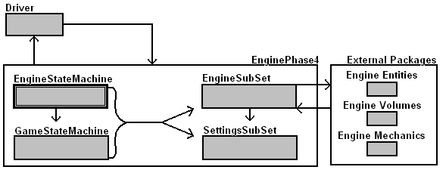
Figure 3.2.1.1 Phase4 Architecture

3.2.2 Functionality of Phase4

All interactions between the driver class and the engine are made through the looping call of the EnginePhase4.RunEngineSlice() method. Please refer to Appendix A Figure 3 for the UML sequence diagram of a single game slice. The EngineSubSet contains most subsystems implemented in the application (except physics management and dynamics management, which are found embedded in the external packages). The sub-components that are the most relevant to this project are EntitySet, EntityManager and the three packages listed in Figure 3.2.1.1, which are self explanatory.

4. Implementation of Solution

As previously mentioned, two subsystems were implemented in the span of this project, in order to support the main concept. These subsystems are particle dynamics and collision detection. The former is completely implemented in the EngineEntities package, and the latter is contained in both the EngineEntities and EngineVolumes packages. The hyperfactor implementation will be discussed afterwards.

4.1 Particle Dynamics

The proper implementation of particle dynamics was one of the most challenging and trickiest parts of the entire prototype. Collision detection and the hyperbelt concept were somewhat straightforward to implement, and required a relatively small amount of code. Particle dynamics, however, required the implementation of several data sets in association with the entity classes. Information such as mass, velocity, acceleration, force, hyperfactor, hypervelocity and hyperforce were necessary in order to have smooth movement results for each dynamical entity. As mentioned before, movement through the hyperbelt was a completely separate system than movement in 3D space. Also, it is much simpler, since it dealt with a single-dimensional coordinate system, as opposed to a three-dimensional coordinate system. Because of this, the discussion of hyperbelt dynamics will be set aside until 3D dynamics are fully explained.

Associated to each dynamical system, an additional variable needed to be added; Air friction and hyper friction. Each of these determined the resistance force applied on the moving entities (whether in 3D space or on the hyperbelt), which represents a small portion of the entity's throttle force, applied in the opposite direction.

The implementation of particle dynamics was split into two methods with two distinct purposes: Calculation and application. The former dealt with the interpretation of user input, and associated it with a resulting acceleration using the mass and throttle force of the current entity. Once this resulting acceleration vector was constructed, the second method applied the results to the velocity and position vectors, followed by the friction reduction. It was also necessary to use the time interval between the current and last application frames, to guarantee a smooth movement interpolation from frame to frame. Table 4.1.1 Represents the ordered steps in which particle dynamics were applied to a single entity.

CalculateDynamics(bool* ThrottleSet)
A.1. Get User Input
A.2. Compute resulting direction
A.3. Normalize vector
A.4. Multiply vector by Force/Mass ratio of entity
ApplyDynamics(float fDt)
B.1. Update positional vector with the following formula
D = Di + ( Vi * t ) + (1/2 * A * t 2 )
B.2. Update velocity vector with the following formula
V = Vi + ( A * t )
B.3. Update the acceleration (negates it for the next frame)
A = 0
B.4 Apply air friction (air friction as percentage of total force)
V = V * (1 - AIR_FRICTION)

Table 4.1.1 Implemented steps for particle dynamics

Step B.1 consists of applying the positional function. This function provides the 3D position of an object as a function of time [LENG04]. The second step, B.2, consists of applying the velocity function. This describes the 3D velocity of an object as a function of time [LENG04]. The third step removes acceleration for the next frame.

In this table, the values D, V and A are 3D vectors. In the hyperbelt, dynamics were computed in the exact same fashion. However, the Force/Mass ratio was computed using the same entity mass, but a different force. This force was called the HyperForce, which determined the applicable force each entity can use to navigate back and forth through the hyperbelt. The AIR_FRICTION was also replaced by a HYPER_FRICTION, but had the same effect.

4.2 Collision Detection

The implementation for collision detection was somewhat simple, and consisted of three main components. It is a relatively young feature in the Phase4 framework, and will be subject to several changes over the next months.

First, the bounding volume instances were declared static in the class definition of each entity type. This ensured that each entity had at least one volume, but remove the freedom of choosing a unique volume for each instance.

Secondly, the method that determined collision checks between two entities was implemented publicly in the abstract CE class. The CE class is part of the engine entity hierarchy (see appendix A Figure 2), and represents the parent class for all entities that are subject to collision in the environment. The method name for collision checks was SphericalCollisionTest, which took two constant references to bounding spheres.

The third component of the system is the method that makes the collision tests between all entities. This method is implemented in the EntityManager class of the framework (see appendix A Figure 1). At each frame, the engine calls RunEnvironmentSlice() in the EntityManager, which deals with all the information changes done on the EntitySet class of the engine. RunEnvironmentSlice then calls ComputeCollisions() in the same class, which consists of an O(n²) algorithm that compares the bounding volumes for collision between each pair of entities.

The hyperfactor plays a critical role in collision detection, since there are no calls to SphericalCollisionTest if the entities are not in hyperscope. This prevents the algorithm to make unnecessary computations to check the 3D collision between two entities that have no chances of colliding.

  - Hyperbelt implementation

The hyperbelt system was implemented using several components. First, each entity needed a hyperfactor, hyperspeed and hyperaccel, which were discussed in the particle dynamics section. Secondly, some sort of special effect was required to show the user the relative position to other entities. Transparency was used to simulate this effect, which increased as the entities got further from the viewpoint. Thirdly, an additional user-interface component was needed, since the user needed extra information to properly navigate through the hyperbelt. This consisted of a red circle around the crosshair(midpoint of the screen forming the orientation of the object) and contained a blue square for each entity's position on the hyperbelt. Figure 4.3.1 demonstrates the hyperbelt heads up display, as seen by the user.

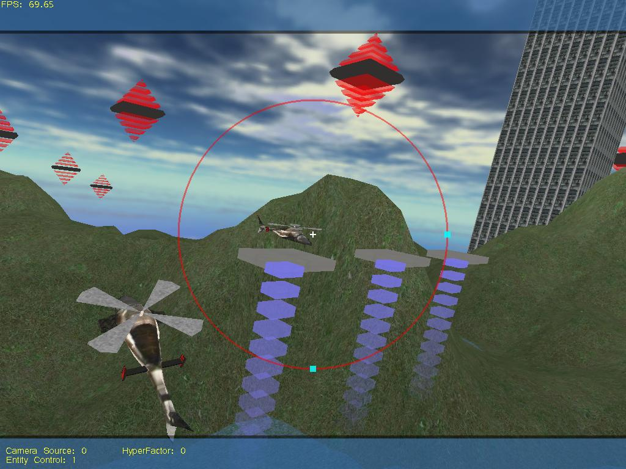
Figure 4.3.1 Real-time snapshot showing the hyperbelt user interface
Conclusion

The hyperbelt environment is a somewhat simple concept that can be applied to several game styles. It opens the door to creativity for 3D action games, role playing games and real time strategy games. The interpretation of the actual hyperbelt in a game application depends on the designers. Whether they choose to interpret it as a series of frozen time frames, allowing entities to move back and forth in time, parallel dimensions or a new system directly affecting physical properties in the world, it would definitely draw attention.

The idea is to present the developers with new grounds to explore, making a game more interesting. The idea of moving back and forth through time using the hyperbelt could be a very interesting application. Each entity could each start at different frozen time frames (one in the 'past', and one in the 'future', represented by opposite positions on the hyperbelt). To interact or battle with each other, they would have to travel through the hyperbelt, which could represent a time value within their control. As they travel, the scene could also have been made dynamic, and change as a function of their hyperfactor, according to what was set to happen in the entire time lapse of the game.

Such applications have never been implemented before in real-time. With the processing power of modern computers, it would be possible to implement such a system. However, moving a dynamic scene as a function of an entity's hyperfactor would require the engine to offer a special kind of environment. The computational geometry of such an environment could be function of a series of NURBS or B-splines, which in turn, would be function of the hyperfactor of the entity in context. Having such a complex building block for the most fundamental elements in a game becomes extremely computationally expensive. Scene management and collision detection with this dynamic scene would also become expensive, and would negate the use of static algorithms, such as binary space partitioning trees.

However, the current prototype was not designed for environments of such complexity. The prototype developed for this concept is still in its early stages of development, and is limited as to what it can do. It does contain, however, every feature previously discussed in this paper, and is still under construction.

From a personal opinion, the creativity drawn from the professional game developers currently working in the game industry could benefit from such a simple concept, regardless of how they would decide to apply it. The hyperbelt is a simple idea, which can be adaptable to several game designs, allowing the creators to develop game features that have never been released before.

Appendix A
Phase4 Architecture

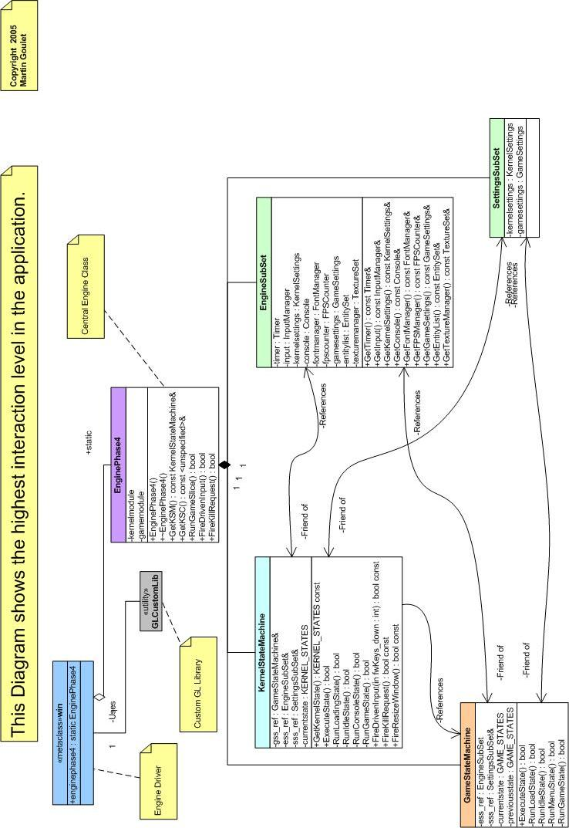
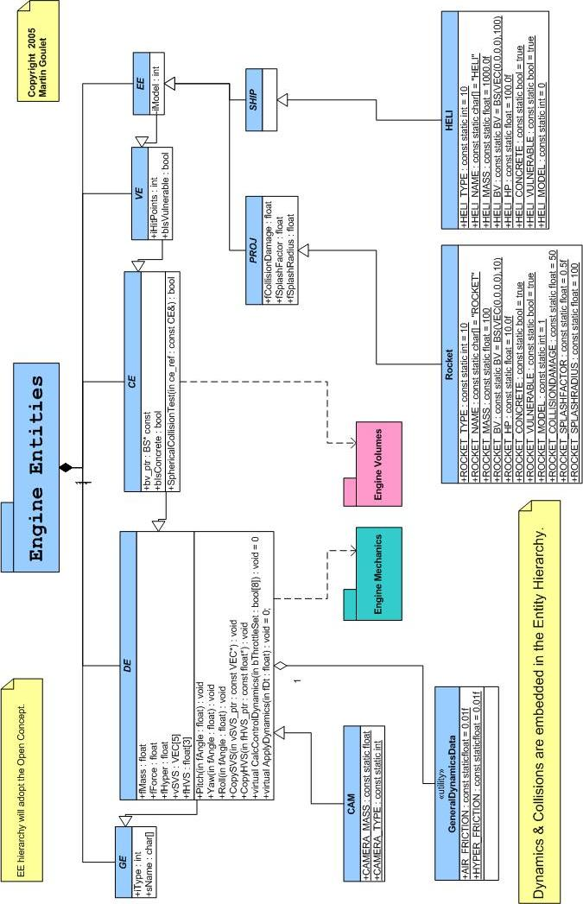
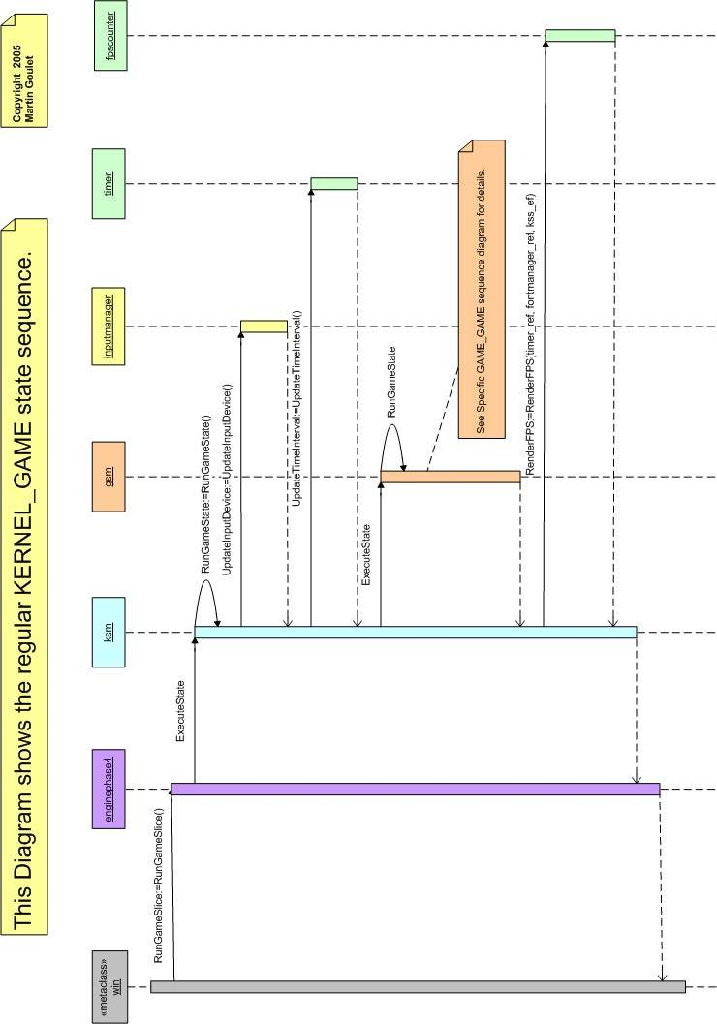
Glossary

'N'D Hyperbelt environment: The idea of expanding an environment of N dimensions to N+1, by introducing an additional axis, perpendicular to the environment of N dimensions and it's replicated parallel set. Furthermore, the axis forms a circular shape, resulting in a cycling navigation of modulo K, such that K is the size of the circle (hyperbelt).

Hyperbelt: The additional (N+1)^{Th} circular axis used in a hyperbelt environment. This axis is perpendicular to the set of parallel N spaces.

Hyperfactor: Represents the position of an entity on the hyperbelt, between 0 and K, such that K is the size of the belt.

Hyperdifference: This is the absolute difference between two hyperfactors belonging to two separate entities.

Hypervelocity: The speed at which an entity travels through the hyperbelt.

Hyperaccel: The acceleration at which an entity travels through the hyperbelt.

Hyperscope: This represents the physical reach of an entity in the hyperbelt environment. The large the value, the larger or thicker the entity would be through the hyperbelt. That is, if a specific entity A wishes to occupy the same environmental space as entity B without colliding, then both entities must have a hyperdifference larger than the sum of both hyperscopes.

References & Resources

LENG04 | Eric Lengyel, Mathematics for 3D Game Programming & Computer Graphics Second Edition, Charles River Media, 2004
ASTL04 | Dave Astle & Kevin Hawkins, Beginning OpenGL Game Programming, Thomson Course Technology, 2004
LANG05 | Jochen Lang, Personal Communication, University of Ottawa Professor & Honours Project Supervisor, Ottawa, Fall 2005
BOOC04 | Booch, Jacobson & Rumbaugh, The Unfied Modeling Language User Guide Second Edition, Addison Wesley, 2004
BERG00 | M. de Berg, M. van Kreveld, M. Overmars & O. Schwarzkopf, Computational Geometry: Algorithms and Applications Second Edition, Springer, 2000
LAND03 | Jeff Lander, Graphics Programming Methods, Charles River Media, 2003
BJOR05 | Staffan Bjork & Jussi Holopainen, Patterns in Game Design, Charles River Media, 2005
BROW04 | Martin Brownlow, Game Programming Golden Rules, Charles River Media, 2004
STRO97 | Bjarne Stroustrup, The C++ Programming Language Second Edition, Addison Wesley, 1997

